UNDP final progress review report to the Delegation of the European Union to Egypt (Contracting Authority)
November 2015 - November 2019 - DRAFT

Title of the action: | Strengthening the capability in the League of Arab States Secretariat and its Member States to provide early warning and effective responses to impending regional crises, conflicts, and post-conflict situations
Location(s) of the action: | Egypt/League of Arab States- 22 Member States- Arab Region
Name of the applicant | UNDP- Regional Bureau for the Arab States
The nationality of the applicant | International Organization

Applicant’s contact details for the purpose of this action
Postal address: | UNDP Regional Hub in Amman  P.O.Box 852303  Amman 11185 Jordan
Telephone number: (fixed and mobile) Country code + city code + number | +96262003177 (Landline)
Fax number: Country code + city code + number
Contact person for this action:
Contact person’s email:
Address: | UNDP Regional Hub for the Arab States  11 Abu Bakr Siraj-Eddin Street, Abdoun, Amman
Website of the Organisation: | arabstates.undp.org

Contents
1 Summary and context of the action 4
Background to EU-LAS-UNDP Collaboration 4
The Region 4
2 Progress against Results in the Description of the Action 5
Project objectives 5
Progress against results and main activities 6
Results Achieved 12
Multiplier effects 13
Risk assessment and management 14

3 Communication Component………………………………………………........……….……….15

4 List of Assets……………………...………………………………….…………...…….….24

list of acronyms
LAS League of Arab States

CMD Crisis Management Department

DPA United Nations -Department of Political Affairs

DPKO United Nations - Department for Peace Keeping Operations

DFS United Nations - Department for Field Support

UNDP United Nations Development Programme

UNITAR United Nations Institute for Training And Research

RBAS Regional Bureau for Arab States

TOT Training of Trainer

SOM Senior Official Meeting

SUMMARY AND CONTEXT OF THE ACTION

Background to EU-LAS-UNDP Collaboration

The origins of this initiative that builds on the ongoing LAS efforts date back to an EU–LAS Memorandum of Understanding (MoU) on crisis response and early warning that was signed in 2009, establishing the basis for long-term institutional cooperation and dialogue in the field of conflict prevention, risk assessment, crisis response and peace-building.
The first phase of cooperation commenced in 2010 to re-enforce the capacity of the League - via its Secretariat - to respond to political, social, economic and environmental crises, through a joint capacity development programme; to operationalize LAS capacity for gathering and channelling early warning signals and their analysis in support of early action and to systematize a long-term dialogue between the LAS and the EU in the fields of risk analysis, crisis response, conflict prevention and peace-building.
The project contributed directly to the establishment and equipment of a Regional Crisis Centre (RCC), which was inaugurated in November 2012, allowing the LAS Secretariat to create the necessary rolling capacity to perform effective crisis-related early warning.
On the basis of the activities and resource investments of Phase I, an institutional capacity within the LAS Secretariat has emerged in the area of crisis response, crisis preparedness and early warning. In the first phase, LAS Secretariat was able to put in place the project's infrastructure and to provide the Crisis Room with the latest equipment to help with data collection and analysis. The current phase of the project has built on the achievements of the first phase. It had four specific objectives:

- Enhance the League of Arab States Secretariat’s technical and institutional crisis management capacity for response to the crisis, conflict, and post-conflict/post-disaster situations
- Contribute to the establishment of an Arab Cooperation Framework and support the building of crisis response capacities in national crisis response entities of the Arab States
- Deepen the policy dialogue between LAS, the EU, and possibly other international/regional organizations
- Mainstream gender in all activities

The Region
The Arab region has been facing different types of crises that are associated with different levels of conflict and instability. These crises have led to serious humanitarian impact, such as in Somalia, with significant displacement and famine in 2011. The war in Syria has led to a refugee crisis in Lebanon and Jordan and has spilled over to Iraq, with serious humanitarian and development impacts there. In 2014, almost 40 percent of the world’s displaced population came from the Arab region, while the region is home to only 5 percent of the world’s population. The share of displaced –more than 16 million– is four times higher than 14 years ago. As such, the Arab region now has one of the highest numbers of refugees in the world, which has put to the test the resilience of both the refugees and the host communities.

In relation to natural disasters, the burden is also significant – but appears less than with man-made crises; cyclones in Oman, drought in Somalia, and floods in Yemen, Sudan, and Tunisia, and pandemics in other countries.

A literature review of man-made crises and natural disasters among the LAS Member States in the period 2009-2014 shows that 71% of Member States have been directly impacted by man-made crises, while 29% were directly impacted by natural disasters (see Table 2 below). All LAS Member States have been indirectly affected, to varying degrees, by man-made crises and natural disasters.

Table 2: The Arab region crisis burden
 | Man-made crises | Natural disasters
Percentage of LAS Member States directly impacted (2009-2014) | 71% (political instability, violent conflict, armed extremist groups) | 29% (pandemics, floods, drought, and cyclones)
Percentage of LAS Member States indirectly impacted by crises and disasters in neighboring countries (2009-2014) | 100% (refugees, border insecurity, arms flows) | 100% (contagion, refugees/migrants)

This project recognized that the institutional capacity to respond to crises and conflicts was critical to avoid vulnerability to conflict and natural disasters. At the same time, the cross-border nature of many man-made crises and natural disasters requires increased regional cooperation. Regional cooperation, however, is often limited to bilateral agreements between the Member States and not linked to a broader regional crisis management architecture. The Cooperation Framework under this phase and its expertise hubs through two task forces intended to facilitate further regional cooperation with dedicated capacity support to be provided to the interested member states.

- Progress against Results in the Description of the Action

Project objectives

This project has contributed to Outcome 2 of the UNDP Regional Programme Document, namely strengthening institutions to promote inclusive participation, prevent conflict and build peaceful societies, with the overall objective to “Strengthen the capability in the League of Arab States Secretariat and its Member States to provide early warning and effective responses to impending regional crises, conflicts, and post-conflict situations.”

Specific objectives:

- Enhance the League of Arab States Secretariat’s technical and institutional crisis management capacity for response to the crisis, conflict, and post-conflict situations;
- Contribute to the establishment of an Arab Cooperation Framework and support the building of early warning and crisis response capacities in national crisis response entities of the Arab States;
- Deepen the policy dialogue between LAS, the EU, and possibly other international/regional organizations
- Mainstream gender in all activities

These objectives have been delivered through initiatives related to:

- The restructuring of the Crisis Management Department (CMD), maintaining and extending achievements from the “Strengthening crisis response capacities of the League of Arab States” project to relevant LAS sectors/departments and the Member States.
- Initiating an Arab Cooperation Framework with the aim of exchange of experience and strengthening collective capacities to respond to different types of crises.
- The creation of expertise hubs of well-trained analysts and practitioners from LAS sectors/departments and Member States (drawn through the Task Forces) who are resourced to deliver training to others. This entails setting up and running LAS/Member State Task Forces on a) Deployment of Field Missions and b) Peace Building (LAS asked later to change the training topics)
Provision of capacity development support through the task forces and other types of assistance to the selected willing member states on early warning and crisis management.
- Policy dialogue and increased coordination between the LAS/Member States, the EU, and possibly other regional/international bodies on crisis issues of mutual interest.

Progress against results and main activities

This section describes progress as per the specific objectives defined in the description of the action (annex 1 of the agreement).

Below are more detailed updates against each result area stipulated in the Description of the Action:

Specific Objective 1: Enhance the League of Arab States Secretariat’s technical and institutional crisis management capacity for response to crisis, conflict, and post-conflict situations

Targeted Result 1: CMD restructured and Phase 1 achievements maintained and extended to relevant LAS sectors/departments and Member States

CMD restructuring process was conducted by UNDP, in collaboration with LAS management, and included essential components such as creating new workflow, recruitment of new staff, updating equipment and software, updating deliverables and designing the training programs of CMD staff.

New organigram and workflow: The CMD has been restructured to include a: (a) Media Monitoring Unit; (b) Analysis Unit; (c) Crisis Response Unit; and (d) Operations and Administration Team. Terms of reference have been prepared for each CMD unit and team; along with required staff profiles. Terms of reference for each unit/team were prepared, covering the unit/team objective, activities, deliverables (including frequency), and an organigram. Staff positions and related job descriptions were finalized according to unit/team terms of reference. From its side, the League of Arab States has taken action to rename the Crisis Department as Crisis Management Department (CMD) according to core areas of service provision.

Qualified staff were recruited: Needs assessment and ToRs for the CMD staff were conducted jointly with LAS and vacancies were advertised. The selection process was made by UNDP and the new staff for each CMD unit and team (5 new staff) were recruited (CTA, 3 research Analysts and Unit Assistant). Other recruitments were made eventually as some staff quit their jobs during the project. The outsourced staff were supposed to be temporary to allow LAS to train its staff to take over when the project comes to an end.

Updating equipment: An assessment of the CMD facility (in terms of tele/video conference facilities, database access points, and equipment status) has been conducted by UNDP as these were purchased during the first phase and some of them were outdated and required updates. The Regional Programme was also fielded its ICT coordinator twice to League of Arab States to inspect the performance of the equipment inside the crisis room, identify the minimum services needed from the room and explore the optimum solutions in order to quickly reactivate the room with its needed technical functions.This process required a budget addendum to finalize the reconfiguration process. This issue was negotiated during the board meeting and the final approval for the addendum was obtained in December 2017.
Based on that, An IT Company was tasked to update and install new softwares and ensure that the equipment is up to date and functioning. As a result, the maintenance and configuration process of the crisis room was completed, and the services are operating in accordance with the project’s requirements. Following the completion of the maintenance and configuration of the crisis room equipment, a final report was finalized by the IT Company and was submitted to LAS. As of to date, all services are operating in accordance with the project’s requirements despite of the fact that some devices are out of maintenance. The video conference device has a technical problem and the company could not solve it. It was recommended to replace the device with a newer model to maintain this service at crisis department (List of equipment purchased are included in the report).

Deliverables: CMD Media monitoring and analytical products were reviewed according to the exchange with senior leadership (including the SG), within LAS. In addition, online database subscriptions were reviewed with feedback from the SG’s office according to identified requirements. In 2017, a meeting was organized with LAS Secretary-General to introduce the CMD workflow and review the current CMD products. According to those assignments, the Arab region was divided into three geographical areas with a special focus on emerging crisis, and daily deliverables were shared with SG as follows:

- News brief about the latest developments in the region.
- Weekly analytical reports.
- A daily summary of political developments.
- Reviews of the most important reports and studies from periodicals and think tanks.
- Assignments from the Secretary-General.

Training: A mapping study of available training sources was conducted by UNDP and the ToRs for the training of the CMD staff on various skills was prepared and a request for quotation was advertised. In 2017, the selected service providers were contacted and a meeting was organized to discuss training goals, agenda, and schedule. Training extended through the second half of 2017, as was originally scheduled as follows:

ResResearch Methods | 21 25 May 2017
MeMedia Monitoring | 16 20 July 2017
AnAnalytical Skills | 6 – 9 August 2017
Reporting | 20 – 23 August 2017

The training was extended to other LAS staff with the aim of building LAS institutional capacities, and not to limit it to CMD. Another training workshop on Strengthening Early Warning and Crisis Response Capacities of the League of Arab States was conducted on the 31st of January 2017.
Based on the new addendum, a training visit to the EU premises was planned to take place in 2018. The objective of the training was to give the staff the chance to get acquainted with the EU working mechanism and exchange views on files of mutual concern. Following the board meeting, a new date was set. UNDP facilitated the process with both the EU and LAS cabinet. The Agenda was developed by the EU and all the logistics were finalised by UNDP team. The visit took place from the 8th till the 11th of July 2019.
The activities above have been critical to build up the capacities of the CMD and restructure its organization as per the identified skills and services. The capacity of the CMD was enhanced to closely follow up the regional crises and provide the SG with timely quality reports on the situations in the affected member states. Overall, the CMD continues to function and regularly produce high-quality reports.

Specific Objective 2: Contribute to the establishment of an Arab Cooperation Framework
Targeted Result 2: Facilitating the process of establishing an Arab cooperation Framework.

The Arab cooperation framework could not be established because some member states were reluctant to act collectively with other on controversial political files. This activity has proved that the member states show more flexibility in activities pertained to capacity building.

Coordinating with member states: The project aimed to establish an Arab Cooperation Framework that could enable the member states to counter collectively the existing regional crises. In the first year, the framework was discussed by senior officials and some recommendations were submitted in this regard to the Ministerial Council of LAS. The ministers did not approve the recommendations and requested further study to explore possible forms of cooperation.
Drafting a study with research centre: The project conducted the requested study jointly with one of the think tanks and recommended to focus on capacity building as the scope of cooperation framework.
Attempts to organize a senior official meeting: Following the postponement of the senior official meeting twice in 2017 due to lack of quorum, the LAS Secretary-General decided not to hold the meeting but rather to organise a capacity building training for the willing member states. During the board meeting that was held on 5th July, 2018, the board changed the scope of this activity to focus mainly on capacity building.
In 2019, LAS suspended all the activities until April’s board meeting when different partners agreed to implement the pending activities. UNDP submitted a modified action plan and agreed with LAS to organize a senior official meeting on collective strategies to help the affected member states in post conflict phase. That was an attempt to initiate a collective action that could evolve overtime with the aim of establishing the desired Pan Arab network. However, the EU requested in its letter dated 20/8/2019 to drop this activity and implement only simulation trainings and gender conference.
Specific Objective 3: Enhancing the operational capabilities of LAS by establishing task forces
Targeted Result 3: Task forces are established by the League of Arab States and become active
Targeted Result 4: Task force members are given an in-depth training of trainers program in (1) Deployment of Field Missions and (2) Peace Building

The task forces was formed from the secretariat of LAS according to certain criteria. Training programs were designed and UNITAR, as the service provider, delivered series of face to face training. Also, two simulation training took place in Italy and Mali.

Formation of task forces: It was planned to establish two Task Forces on (1) Deployment of Field Missions, and (2) Peace Building. The task forces were envisaged to serve as expertise hubs to support the member states on demand basis. These expertise hubs would form a critical mass of expertise to support preparations and responses to key crises in the region.
In 2017, the SG approved the formation of the task forces and decided to limit it to LAS members staff. It was agreed that the two task forces will be trained on the following: Deployment of field mission – Peace Operations. An announcement for Task forces formation was advertised through the LAS training department for interested staff members to apply for the training. The selection process was finalized and 50 LAS staff members were selected from different departments to join the training. Task Force members were selected from the LAS Secretariat based on criteria drawn on the basis of the terms of reference.

Selection of service provider: A mapping study was conducted to identify available alternative training centres that could be utilized for the capacity support program for the task forces. The ToRs for designing and delivering the training streams for the task forces were prepared to target the mapped institutions. UNITAR was selected to conduct the first patch of the training. Later on, A 3-year partnership agreement was concluded between UNDP and UNITAR to deliver the additional training and simulations planned in the project.

Designing the training programs:
Conducting needs assessment: In 2017, a detailed capacity – needs assessment was carried out to determine task force member training. An internal meeting with LAS officials was held to prepare for the informal consultations. Some decisions were taken to change the scope of the activities and focus on the post-conflict ones. UNDP deployed a senior advisor and a consultant to conduct the study and provide advice to LAS for this purpose.
Conducting consultations with other organizations: The idea of establishing operational capacities at LAS required an exchange of experience with international organizations. Hence, UNDP facilitated a meeting with different international organizations with the aim of benefiting from their longstanding experiences in field operations. The informal consultations event was held on 30-31 January, 2018. The two-day event brought together representatives from LAS, the United Nations Institute for Training and Research (UNITAR), UNDP, EU, UN Department of Political Affairs (DPA), UN Department of Field Support (DFS), and UN Department of Peacekeeping Operations (DPKO). Participants presented their experiences in the realm of crisis response, peace operations, and pre-deployment training, and exchanged views on how to best tailor the training for the LAS task forces in order to meet their objectives.

The consultations were very fruitful and offered LAS a good opportunity to establish channels of cooperation with international organisations. The DFS has extended an invitation to LAS discuss how they might access, on a case by case basis, equipment stocks stored in the UN Global Support Centre in Brindisi (Italy) once LAS has conducted assessment and developed a clear vision of their needs. DFS also invited LAS to discuss how they might participate in a staff exchange programme that could contribute toward LAS capacity building in skills related to ‘mission planning and management’ and the possibility to benefit from a Senior Mission Administration and Resource Training (SMART), which is designed to develop the skills of middle and senior level managers.

Delivery of training programs: Based on the outcomes of the consultations, the project team, jointly with UNITAR, developed a training program and started the training process for LAS task force.

- Prior to the first face-to-face training, participants were asked to complete four online modules during March, and they were expected to score a minimum of 80% in order to move on to next phase. The training was delivered to 26 task force members from 17 April to 10 May 2018. The training programs covered different topics including:
- Introduction to Pre-Deployment based on the UN Core Pre-Deployment Training;
- Introduction to Conflict Analysis;
- Introduction to Data Collection, Monitoring, and Reporting;
- Introduction to Negotiation, Conflict Resolution and Mediation in the Field
- Building Partnerships;
- Stress, Trauma and Building Resilience;
- Leadership and Communication Skills in the Field.

- Another training was delivered for 25 LAS task force members between 16 and 27 September, on “Advanced missions and logistics planning”.
- A simulation took place in Brindisi, Italy, 28 January – 8 February 2019 on Logistics in UN Peace Operations facility. Accordingly, 22 of LAS task forces were given extensive hands-on training on mission startup, pre-deployment and mission’s logistics.
- A Face to Face training on PKO mandate implementation took place in Cairo, 7 April – 18 April 2019, and tackled topics such as Protection of civilians, CIMIC, humanitarian actors in conflict and DDR.
- Training of Trainers also took place in Cairo, 18 – 22 August 2019 to train the staff of LAS secretariat. UNITAR provided a list of 5 suggested members based on specific selection criteria. The list was reviewed and finalized by LAS and a final list of 6 members was agreed upon. It was agreed with UNITAR that the TOT training will not focus only on the presentation and delivery skills but also will be extended to other topics related to the content. The main idea behind this was to allow the trainers to practice the content that they will deliver in the future. The training phase comprised two stages as follows:
- An online training for 2 weeks accompanied by two webinars with UNITAR trainers recap and to answer any questions related to the online course content. The two webinars were conducted respectively on the 25th of June and 1st of August 2019.
- A face to face training will take place from the 18th till the 22nd of August 2019 in Cairo. The final report recommended additional Training of Trainers Courses focused on content. This would allow the participants to reach more depth with respect to both training skills and delivering on specific peacekeeping topics.
- Simulation in Mali: Finally, a simulation training on Peace Keeping Operations mandate implementation took place in Bamako, Mali, 21 – 31 October 2019. UNDP requested UNITAR to provide several suggested facilities based on certain comparison criteria which included: Facilities overall evaluation, security risks, the likelihood of hosting the training event, accommodation of participants and nature of work. Accordingly, UNITAR suggested 4 possible locations which included: Musanze, Rwanda - Bamako, Mali - Stockholm, Sweden - Versoix, Switzerland. This list was shared with LAS and Mali was chosen for the simulation. The Simulation took place and the task force received training on the following offices : Joint Operations Centre, Joint Mission Analysis Centre, Stabilization & Recovery Office, Civil Affairs Office, Protection of Civilians, DDR Office and Political Affairs Office. Also, the training included a field visit to MINUSMA where the staff discussed with the mission different issues related to real working environment. UNDP and UNITAR handled all the logistical sides of the mission (accommodation, flights, transportation, etc.).

Specific Objective: Deepened policy dialogue between LAS, the EU, and other international/ regional organizations

Targeted Result 5: The LAS/Member States the EU (in the framework of the EU-LAS Strategic Dialogue), and possibly other regional/international bodies deepen their policy dialogue and increase coordination on crisis-related issues of mutual interest

The activities under this objective did not start in 2016 and was expected to start at a later stage, once the project’s substantive work is initiated and the CMD becomes fully operational. It was envisaged that LAS will engage with the EU and, possibly other regional/international bodies, to agree on an annual dialogue theme/format. This activity could not be implemented as the project document did not indicate clearly the possible areas of dialogue and both sides could not agree on topics of mutual concern.

Coordination with EU and LAS: In 2017, the EU did not identify the topics of the policy dialogue of common interest and its view regarding the possibility of merging the activity with the strategic dialogue (An existing agreement between the EU and LAS). The activity was postponed until 2018.
Though, the Crisis Department participated in the third session of the Strategic Cooperation Working Group on "Crisis Management and Early Warning" at the European Council in Brussels on the sidelines of the meeting of Permanent Representatives of the League of Arab States with members of the European Union's (PSC) 28, the issue of the policy dialogue was not solved.

In 2018, UNDP followed up with both LAS and the EU to develop a concrete action plan that could lead to the implementation of the policy dialogue. The issue was discussed during the project board meeting in July 218. There, partners expressed the need to further clarify the objective of the policy dialogue to avoid any overlapping with the already existing structures between LAS and the EU, such as the Strategic Dialogue.

Following the meeting, a draft proposal was shared by the EU suggesting to facilitate a permanent working contact/exchange between LAS and the EU for information sharing on mechanisms and tools of crisis response (which would feed into the Strategic Dialogue) as well as allowing discussion on concrete crises and responses to them to support the SOM meetings. In its feedback, LAS highlighted the difficulties associated with the implementation of this idea and proposed to hold an annual event on a theme of mutual interest.
In 2019, the Policy dialogue activity was discussed as an item on the agenda of the project’s tripartite board meeting which took place on the 15th of April 2019. Again, different partners expressed the need to further clarify the objective of the policy dialogue, as stated in the project document. LAS and EU failed for two consecutive years to reach a formula that could find a new area of cooperation. LAS suggested in the Board meeting to organize the policy dialogue event on a topic related to sustainable development in post conflict phase or economic issues of benefit the affected the member states. In its response to this idea, the EU indicated that “the policy dialogue component can be dropped at this point because these are (the suggested ideas) unfortunately not falling into the scope of this project”.

Specific Objective: Crosscutting results to mainstream gender in activities

Targeted Result 6: Cross-Cutting Result: Focus on Gender

The scope of this activity was amended; a conference on the role of women in post conflict societies was organized.

Attempts to implement the gender component: LAS engaged with a regional women organization called Karama, to conduct dedicated activities as per the action’s envisaged results. UNDP communicated with KARAMA to discuss the component and explain how to deliver different activities. In 2017, Karama failed to submit a proposal on how to deliver the regional gender analysis in crisis, conflict, and post-conflict situations, as well as adapting the existing tools for gender analysis in such settings. LAS started communicating with alternative institution called Baseera to discuss how to conduct the gender activity. In 2018, several meetings were arranged with Baseera, however, it also failed to provide a sound proposal and quotation that matches the UN contractual procedures. Accordingly, the board meeting acknowledged the inability of local organizations to provide a comprehensive technical and financial offer for this component and suggested to focus on the organization of a high-level conference to exchange good practices on the role of women in crisis and post-crisis situations.

Organizing a conference on the role of women in post conflict societies: The Project management communicated with LAS chief of Cabinet and Social Sector to start working on different aspects related to the conference. The concept note and agenda were drafted and shared with different partners in cooperation with LAS women department. Invitations were sent out to a list of participants based on recommendations from LAS/EU/UNDP. The project management jointly with Beirut office handled all the logistics of the conference (meeting room/ list of participants/ flight tickets/ accommodation/ pick up, etc.). A consultant was hired to draft the final report and recommendations based on the inputs of participants. A coordination meeting was organized by the CTA to ensure that the outcome of the conference will reflect the views of the three organizations (EU/UNDP/LAS). The conference was held in November 2019 with the participation of several Arab ministers, EU Ambassadors, gender experts and media. The project management shared the recommendations with different partners and made sure that it was adopted collectively. The conference came up with important recommendations regarding the role of women in post conflict societies and reflected the stance of the Arab countries in this regard. LAS will share the outcomes of this conference with different international forums and member states.
Printing and translating the final report and recommendations: UNDP agreed to cover the expenses of printing and translating the recommendations of the conference as it was not possible to spend money for this purpose from the budget of the project after the expiration date.

Results achieved

- LAS CMD is functioning efficiently with a group of qualified and well-trained staff who are able to provide the decision-making system at LAS with a quality report on the political developments in the Arab region. In addition, the equipment was fully maintained and could function perfectly until the end of the project (and beyond).
- Task Forces established on post-conflict activities with clear terms of reference that is appropriately composed and adequately funded to be ready to be deployed in the affected areas when needed.
- LAS established channels of cooperation with the UN and EU in the field of field missions as a result of the informal consultations held among different entities and LAS. Moreover, the outcome of this meeting paved the way for further collaboration in times of deployment.
- A systematized interregional and global dialogue process implemented between LAS, EU and possibly other interested parties. It is foreseen that LAS will engage with the EU in a dialogue that will tackle the regional crises of mutual interest, taking into consideration the commitments of the Strategic Dialogue.

Multiplier effects

There are three components to this action that will have direct multiplier effects: (a) a better performing CMD; (b) a critical mass of Secretariat officials in Task Forces who can train staff in their own institutions; (c) an active group of Task Forces who work together on building crisis response capacity and are able to be deployed for technical assistance

A better performing CMD Improved CMD performance (staff rationalization, clear terms of reference, better use of resources, clearer target audience, training, etc.) which over time added value to the Secretariat and the evidence-base used by different sectors/departments for crisis-related activities.

A critical mass of Secretariat officials in Task Forces who will train staff in their own institutions effectively trained and resourced Secretariat officials in Task Forces who can train others sets the stage for a clear multiplier effect.

An active group of task forces who work together on building crisis response capacity and are ready to be deployed for technical assistance upon request. Supporting the creation of task forces as expertise hubs and the introduction of deployment plans establishment of relationships between Member State crisis management institutions is likely to lead to additional bilateral engagements among them. It is also hoped that active engagement of task forces on the provision of technical assistance the activities envisaged in this action will facilitate relationships between Member State crisis management institutions.r

Risk assessment and management

The logical framework for this action outlines a number of risks and assumptions during the project lifetime. The most important ones are given in Table below, along with recommended risk management strategies. Others listed are addressed in project activities.

Identified risks | Risk management
Risks related to the change in LAS management, the matter that delayed the implementation of the previously agreed upon activities | Several requests were made to meet LAS officials, especially the chief of cabinet, to discuss the situation and express concern. The Director of UNDP Regional Hub met with LAS chief of Cabinet for solving pending issues. Also, the EU was briefed regularly about the situation and hence, a request was sent by UNDP to LAS officials to hold a board meeting with the aim of ensuring the implementation of the project’s activities before the end of November 2019.
Risks related to the sustainability of the CMD deliverables due to the imminent end of the project and the unavailability of enough LAS staff | Given that the project came to an end in November 2019, all the outsourced employees quit their jobs. LAS was informed repeatedly about the need to recruit/ move some employees to CMD to ensure the sustainability of deliverables.
Risks related to the non-Functional software and hardware equipment within the CMD | Software maintenance and upgrading process was completed, with all equipment functioning efficiently. Due to the completion of the project, the IT maintenance company will no longer conduct its regular visits and LAS will have to follow up accordingly.
Risk related to the change of some employees due to unexpected developments such as receiving better offers or their desire not to renew contracts | Online vacancies were published, and new candidates were interviewed. New staff were immediately hired to fill in until the hiring process is finalized
Risks related to lack of/ absence of institutionalization of the task force and its working mechanism at LAS | This challenge was mitigated through the continuous communication with LAS officials. The risk was discussed during April’s Board Meeting of the year 2019. The termination of the project might have a negative impact on the continuity of the task force.
Risks related to the reluctance of some Arab states to approve the Arab Cooperative framework in the field of capacity building | It was agreed by LAS that the activities will be organized to the willing states only.
Risks related to the inability to establish a regular and structured policy dialogue on crisis response between LAS and the EU | Communicate with different partners and refer the issue to the board meeting to act accordingly. Some ideas were suggested but the EU did not approve them.
Risks related to finding a service provider to implement the gender activity | It was agreed to focus on the organization of a high-level conference/seminar to exchange good practices on the role of women in crisis and post-crisis situations and eventually discuss protection mechanisms in the Arab World.
Risks regarding the political changes in the region that affected the implementation of some activities | The project activities were reviewed regularly to adapt with the new realities. The project board showed more flexibility to change/redesign some activities.
LAS requests to increase the budget allocated for some activities or to alternate new activities | The budget and administrative procedures were discussed with LAS officials. The management referred any pending issues to the board meeting as the governing body.

- Communication Component

The strategy sets up approaches and tools in order to keep the stakeholders regularly informed and to ensure the visibility of the project. On visibility, the strategy contains the activities to be undertaken by the implementing partner. Activities were designed to build a communication and visibility plan that will highlight the participation of the European Union (EU), the United Nations Development Programme (UNDP) and the League of Arab States (LAS) in this project.

1. Communication activities

Main activities that took place during the period were covered as follows:

Project’s visibility

Brussels visit:

An article with the visit imageries was posted on UNDP RBAS newsletter,
http://rbas-rpnewsletter.org/
In addition to a teaser tweet from internal COM. team pointing to the article link,
https://twitter.com/MutoAlessandra/status/1154312706490589184
Followed by a tweet @UNDPARABIC disseminated the visit, with the tagging #EU, #crisis #Europe aid and #LAS,
https://twitter.com/undparabic/status/1151515673983672320?s=21

TOT training

Professional footage material were conducted and uploaded to the shared folder to be used in upcoming activities. (video attached)
A tweet was circulated @UNDPARABIC,
https://twitter.com/UNDPArabic/status/1164496627534630912?s=20
Coordination with the UNITAR Coms team for a tweet and a Facebook post with all required content and images,
https://twitter.com/UNITAR/status/1165934441979621376
Followed by a tweet after the completion of the training internally,
https://twitter.com/MutoAlessandra/status/1164503213376253953

Mali simulation

A tweet was circulated @UNDPARABIC.
https://twitter.com/UNDPArabic/status/1188430854856630272
A Facebook post with link below were pushed online.
https://www.facebook.com/UNDPar/photos/pcb.3098339596848005/3098339460181352/?type=3&__tn__=HH-R&eid=ARCZfQVp2Vjl06Jdgoe00uDnNaf_CyEpAXHd2mMgPUR6bMEaEF1c4RWmVztP0h5AqStlZoZAwx4G1kRy
Professional footage material were conducted and uploaded to the shared folder to be used in upcoming activities.
25x package of visibility material were distributed to the simulation participants.

Gender conference in ------on 20th and 21st of November 2019

- Twitter Moment:

• The link below has all posts with the hashtag #Women4PeaceAR, followed by the hashtag reach reports.
https://twitter.com/i/moments/1197150451654893570
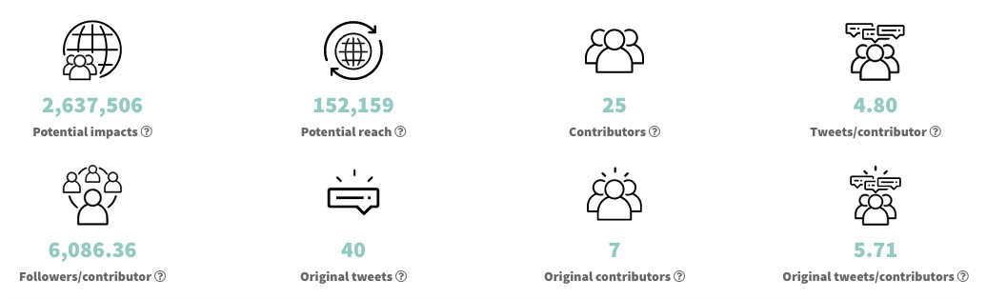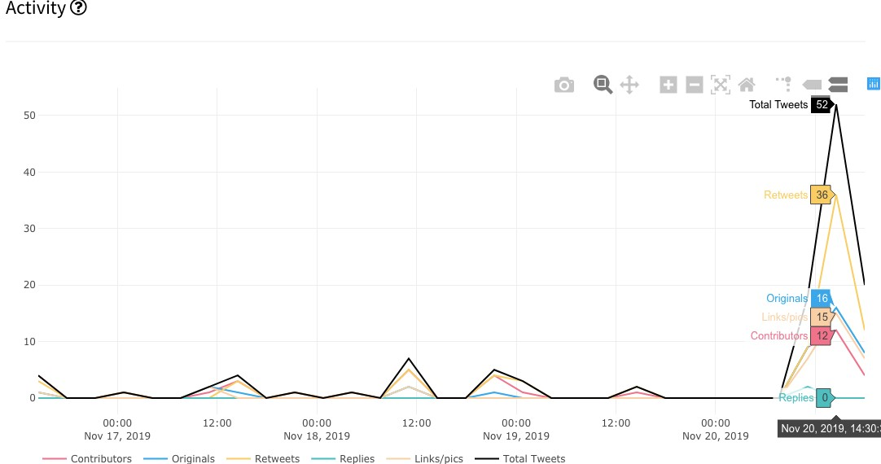
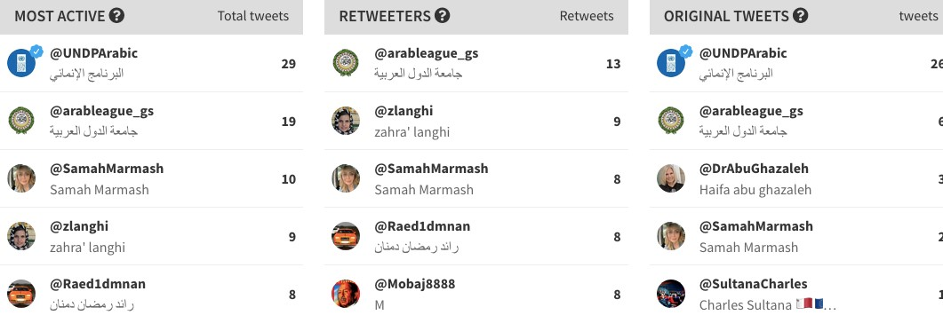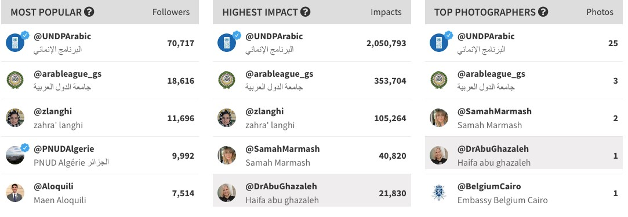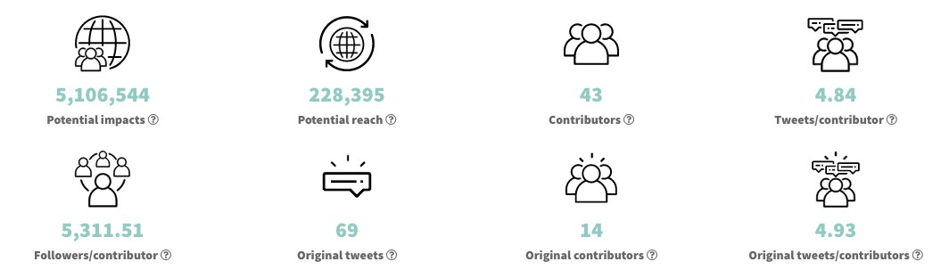
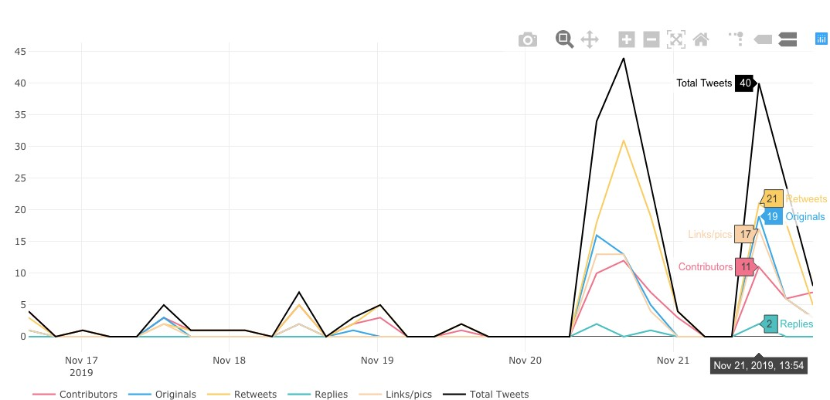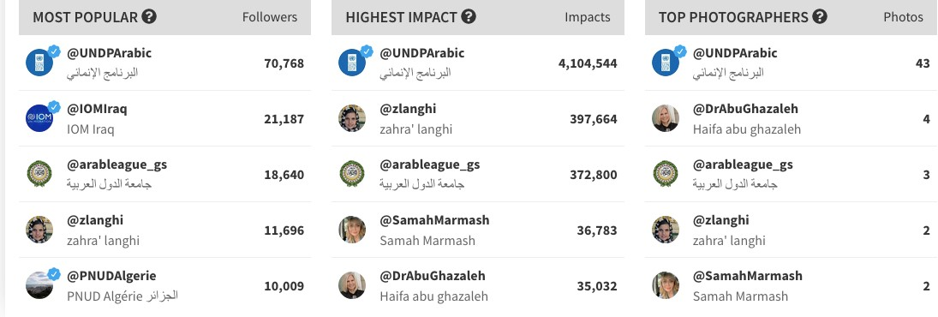

- News reports (press release):

اليوم الجديد •

http://elyomnew.com/news/Details/28653?n=%C2%AB%D8%A7%D9%84%D9%82%D9%88% D9%85%D9%8A_%D9%84%D9%84%D9%85%D8%B1%D8%A3%D8%A9%C2%BB:_%D8%A7%
D9%84%D8%B3%D9%8A%D8%B3%D9%8A_%D9%85%D9%86_%D8%A3%D9%88%D8%A7%D
8%A6%D9%84_%D8%A7%D9%84%D8%B1%D8%A4%D8%B3%D8%A7%D8%A1_%D8%A7%D9
%84%D8%B0%D9%8A%D9%86_%D8%AA%D8%B5%D8%AF%D9%88%D8%A7_%D9%84%D9%
84%D8%A7%D8%B3%D8%AA%D8%BA%D9%84%D8%A7%D9%84_%D8%A7%D9%84%D8%A C%D9%86%D8%B3%D9%8A_
- NCW Egypt:

http://ncw.gov.eg/ar/%D8%AA%D8%B9%D8%B2%D9%8A%D8%B2-%D8%AF%D9%88%D8%B1%D8%A7%D9%84%D9%85%D8%B1%D8%A3%D8%A9-%D9%81%D9%89- %D9%85%D8%AC%D8%AA%D9%85%D8%B9%D8%A7%D8%AA-%D9%85%D8%A7-%D8%A8%D8%B9%D8%AF-%D8%A7%D9%84%D8%B5%D8%B1/

- Lusail news:
https://lusailnews.net/article/politics/qatar/20/11/2019/%D9%82%D8%B7%D8%B1%D8%AA%D8%B4%D8%A7%D8%B1%D9%83-%D9%81%D9%8A-
%D8%A7%D9%84%D9%85%D8%A4%D8%AA%D9%85%D8%B1-
%D8%A7%D9%84%D9%88%D8%B2%D8%A7%D8%B1%D9%8A-%D8%AD%D9%88%D9%84-
%D8%AA%D8%B9%D8%B2%D9%8A%D8%B2-%D8%AF%D9%88%D8%B1-
%D8%A7%D9%84%D9%85%D8%B1%D8%A3%D8%A9-%D9%81%D9%8A-
%D9%85%D8%AC%D8%AA%D9%85%D8%B9%D8%A7%D8%AA-%D9%85%D8%A7-%D8%A8%D8%B9%D8%AF-
%D8%A7%D9%84%D8%B5%D8%B1%D8%A7%D8%B9%D8%A7%D8%AA
- Ahram news:
http://gate.ahram.org.eg/News/2327826.aspx
- Shorouknews:
https://www.shorouknews.com/news/view.aspx?cdate=20112019&id=6c298333-b947-4f6c-8bad6a51c3ca1641
- Akhbar alyoum:
https://m.akhbarelyom.com/news/NewDetails/2948912/1/%D9%85%D8%A7%D9%8A%D8%A7%D9%85%D8%B1%D8%B3%D9%8A-%D8%AA%D8%B4%D8%A7%D8%B1%D9%83-
%D8%A8%D9%81%D8%B9%D8%A7%D9%84%D9%8A%D8%A7%D8%AA--
%D8%AA%D8%B9%D8%B2%D9%8A%D8%B2-%D8%AF%D9%88%D8%B1-
%D8%A7%D9%84%D9%85%D8%B1%D8%A3%D8%A9-%D9%81%D9%8A-
%D9%85%D8%AC%D8%AA%D9%85%D8%B9%D8%A7%D8%AA-%D9%85%D8%A7-%D8%A8%D8%B9%D8%AF-
%D8%A7%D9%84%D8%B5%D8%B1%D8%A7%D8%B9-%D9%81%D9%8A-
%D8%A7%D9%84%D9%85%D9%86%D8%B7%D9%82%D8%A9-
%D8%A7%D9%84%D8%B9%D8%B1%D8%A8%D9%8A%D8%A9-
- Baladna al youm:
https://www.baladnaelyoum.com/news/5dd50b3ea24321318e7f7563/%D8%AA%D8%BA%D8%B7%D 9%8A%D
8%A7%D8%AA-
%D9%88%D9%85%D8%AA%D8%A7%D8%A8%D8%B9%D8%A7%D8%AA/%D8%A7%D9%86%D8%B7%D9%84%
D8%A7%D9%82-%D8%A7%D9%84%D9%85%D8%A4%D8%AA%D9%85%D8%B1%D8%A7%D9%84%D9%88%D8%B2%D8%A7%D8%B1%D9%8A-%D8%AD%D9%88%D9%84-
%D8%AA%D8%B9%D8%B2%D9%8A%D8%B2-%D8%AF%D9%88%D8%B1-
%D8%A7%D9%84%D9%85%D8%B1%D8%A3%D8%A9-%D9%81%D9%8A-
%D9%85%D8%AC%D8%AA%D9%85%D8%B9%D8%A7%D8%AA-%D9%85%D8%A7-%D8%A8%D8%B9%D8%AF-
%D8%A7%D9%84%D8%B5%D8%B1%D8%A7%D8%B9-
%D8%A8%D8%A7%D9%84%D9%85%D9%86%D8%B7%D9%82%D8%A9-
%D8%A7%D9%84%D8%B9%D8%B1%D8%A8%D9%8A%D8%A9
- Al balad:
https://www.elbalad.news/4065257
- Al bawaba news :
https://albawabhnews.com/3805470
- Dostor:
https://www.dostor.org/2913730

- Emirates News Agency:
http://www.wam.ae/ar/details/1395302804792
- Saudi Prss Agency:
https://www.spa.gov.sa/2000786
- Al balad news:
https://www.elbalad.news/4065257
- Sada Al Arab:
https://www.sada-elarab.com/179721
- Rum News:
http://www.rumonline.net/index.php?page=article&id=488114

انباء اليوم
https://anbaaalyoum.com/%D8%BA%D8%AF%D8%A7-%D9%85%D8%A4%D8%AA%D9%85%D8%B1%D9%88%D8%B2%D8%A7%D8%B1%D9%8A-%D8%AD%D9%88%D9%84%D8%AA%D8%B9%D8%B2%D9%8A%D8%B2-%D8%AF%D9%88%D8%B1-
%D8%A7%D9%84%D9%85%D8%B1%D8%A3%D8%A9-%D9%81%D9%8A/
- Aawsat:
https://aawsat.com/home/article/2002331/%D9%85%D8%A4%D8%AA%D9%85%D8%B1-%D9%81%D9%8A%D8%A7%D9%84%D9%82%D8%A7%D9%87%D8%B1%D8%A9-%D9%8A%D8%AF%D8%B9%D9%88%D9%84%D8%AA%D8%A3%D8%B3%D9%8A%D8%B3-%D9%85%D8%B1%D8%A7%D8%B5%D8%AF-
%D9%84%D9%84%D8%A7%D9%86%D8%AA%D9%87%D8%A7%D9%83%D8%A7%D8%AA-%D8%B6%D8%AF-
%D8%A7%D9%84%D9%86%D8%B3%D8%A7%D8%A1-%D9%81%D9%8A-
%D9%85%D9%86%D8%A7%D8%B7%D9%82-
%D8%A7%D9%84%D9%86%D8%B2%D8%A7%D8%B9%D8%A7%D8%AA
- Eg elyoum:
https://www.egelyom.com/%d8%ba%d8%af%d8%a7-%d9%85%d8%a4%d8%aa%d9%85%d8%b1%d9%88%d8%b2%d8%a7%d8%b1%d9%8a-%d8%ad%d9%88%d9%84-
%d8%aa%d8%b9%d8%b2%d9%8a%d8%b2-%d8%af%d9%88%d8%b1-
%d8%a7%d9%84%d9%85%d8%b1%d8%a3%d8%a9-%d9%81%d9%8a/
- Masrawy:
https://www.masrawy.com/news/news_egypt/details/2019/11/20/1674310/%D9%85%D8%A7%D9%8A%D8%A7-%D9%85%D8%B1%D8%B3%D9%8A-
%D8%AA%D8%B4%D8%A7%D8%B1%D9%83-%D9%81%D9%8A-%D9%85%D8%A4%D8%AA%D9%85%D8%B1-
%D8%AA%D8%B9%D8%B2%D9%8A%D8%B2-%D8%AF%D9%88%D8%B1-
%D8%A7%D9%84%D9%85%D8%B1%D8%A3%D8%A9-%D9%81%D9%8A-
%D8%A7%D9%84%D9%85%D9%86%D8%B7%D9%82%D8%A9%D8%A7%D9%84%D8%B9%D8%B1%D8%A8%D9%8A%D8%A9-

- Press Videos coverage :

  - Nile News:
https://youtu.be/xt8PI7GVSoY

  - CBC extra https://www.youtube.com/watch?v=pDLpg80A7PY&feature=youtu.be

  - (MSNFCF) وزارة التضامن الوطني و الأسرة و قضايا المرأة: https://youtu.be/DYiwHE61EZ4
الجمهورية •
https://m.gomhuriaonline.com/%D8%A7%D8%A8%D9%88%20%D8%BA%D8%B2%D8%A7%D9%84% D8%A9%20%D8%A7%D9%84%D9%85%D8%B1%D8%A3%D8%A9%20%D8%A7%D9%84%D8%B9%D8
%B1%D8%A8%D9%8A%D8%A9%20%D8%B9%D8%A7%D9%86%D8%AA%20%D9%81%D9%8A%20%D
8%A7%D9%84%D8%B3%D9%86%D9%88%D8%A7%D8%AA%20%D8%A7%D9%84%D8%A3%D8%AE%
D9%8A%D8%B1%D8%A9%20%D8%A8%D8%B3%D8%A8%D8%A8%20%D8%A7%D9%84%D9%86%D8
%B2%D8%A7%D8%B9%D8%A7%D8%AA%20%D8%A7%D9%84%D9%85%D8%B3%D9%84%D8%AD% D8%A9/513972.html
الديار: •
http://www.eldyar.net/show82579

  - M24TV:
https://youtu.be/nwJ6jb3xVt0

  - TeN TV:
https://eur03.safelinks.protection.outlook.com/?url=https%3A%2F%2Fyoutu.be%2F2p1B1SoOtxg&amp;data= 02%7C01%7Cbassant.mansour%40undp.org%7Ce64f916971ab4b5957ef08d76f872ad3%7Cb3e5db5e2944483 799f57488ace54319%7C0%7C0%7C637100498630713723&amp;sdata=MVAY%2Fb7SRAXVu1qEqV6QEnoIALZa cyj65tl%2FYnE%2FRiU%3D&amp;reserved=0
  - وكالة أنباء الشرق الأوسط: https://youtu.be/2CvWCxxoLdo
  - Sout Al Arab:
https://www.youtube.com/watch?v=SOTfFrOONg4

- Visibility materials

  - Booklet for speaker’s bios was circulated during the event.
  - Teaser for the promo published before the event. (1:18 minutes)
  - Promo on LAS efforts for WPS. (5:00 minuets)
  - Giveaways for attendees:
Leather notebooks, pens and project brochure in both languages Arabic and English.
  - Media advisory pre-event.
  - Press release with final recommendations. (25-11-2019)

Communication group participation

Participation at the meetings that were held on the 25th of July, 11th of September and 6th of November. As part of participating in the Regional Programme Social media engagement, four tweets, one Facebook post and one Instagram post, were enrolled in the CG SoMe sheet to be pushed online from August to October 2019.

Visibility Materials

Items | EUD | UNDP | MALI Team | Gender conference | LAS  Task-force  Participants | Others | Total  X 500
USB | 50 | 20 | 24 | 200 | 20 | 4) PM (samples)  7) Las cabinet. | 175
ID card holder | 50 | 20 | 24 | 200 | 20 | 4) PM (samples)  7) Las cabinet. | 175
Block note | 50 | 20 | 24 | 200 | 20 | 4) PM (samples)  7) Las cabinet. | 175
notebook | 50 | 20 | 24 | 200 | 20 | 4) PM (samples)  7) Las cabinet. | 175
Plastic pen | 50 | 20 | 24 | 200 | 20 | 4) PM (samples)  7) Las cabinet. | 175
Metal pen | 50 | 20 | 24 | 200 | 20 | 4) PM (samples)  7) Las cabinet. | 175
clipboard | 50 | 20 | 24 | 200 | 20 | 4) PM (samples)  7) Las cabinet. | 175
Brochure Arabic | 50 | 20 | 24 | 200 | 20 | 4) PM (samples)  7) Las cabinet. | 175
Brochure English | 100 | 20 | 24 | 200 | 20 | 4) PM (samples)  7) Las cabinet. | 175
Bags | 50 | 20 | 24 | 200 | 20 | - | -
Leather folder | 50 | 20 | 24 | 200 | 20 | 4) PM (samples)  7) Las cabinet. | 175

- List of Assets

UNDP Assets
NO | Description | Model | Serial ID
5 | MONITOR | DELL | 3GQQD52
5 | MONITOR | DELL | 3G5QD52
5 | MONITOR | DELL | 3GXND52
5 | MONITOR | DELL | 3BBRD52
5 | MONITOR | DELL | 3BSPD52
5 | NOTEBOOK | DELL LATITUDE E7450 | F347J72
5 | NOTEBOOK | DELL LATITUDE E7450 | C4G6J72
5 | NOTEBOOK | DELL LATITUDE E7450 | J8G6J72
5 | NOTEBOOK | DELL LATITUDE E7450 | 9P16J72
5 | NOTEBOOK | DELL LATITUDE E7450 | BR41J72
4 | DOCKING STATION | DELL
4 | DOCKING STATION | DELL
4 | DOCKING STATION | DELL
4 | DOCKING STATION | DELL
2 | PRINTER | HP LASER JET PRO M426DW | PHB8HDP1BP
2 | PRINTER | HP LASER JET PRO M402DN | PHCPF16837
**** The List above contains all the equipment that were purchased during the implementation process for the project’s staff. The equipment were used by UNDP and CMD staff for the last three years. The department relies on them to perform the requested tasks. UNDP recommends to hand over these items to the beneficiary in order to make sure that the CMD will continue providing the regular deliverables.

Nyheim, D. (2014) “Strengthening Crisis Response Capacities of the LAS and Member Countries - Desk Review of Crisis and Crisis Response in the Arab Region” Report prepared for UNDP, 24 August 2014. Unpublished.
Nyheim, D. (2014) “Strengthening Crisis Response Capacities of the LAS and Member Countries - Desk Review of Crisis and Crisis Response in the Arab Region” Report prepared for UNDP, 24 August 2014. Unpublished.

